User Manual

SkillCourt Backend

Florida International University

Senior Project 2015

Contents

Creating a new Account: 2

Account Management: 3

Guest Access: 4

Logging In: 5

Logging Out: 6

Routine Selection: 7

Access Performance Statistics: 8

# Creating a new Account:

At the end of this section, you will be able to create your personal SkillCourt Player account that you can use to access all SkillCourt Player features.

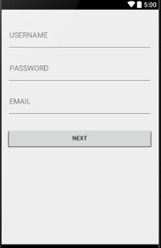

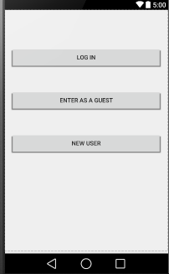

Step 1: Click the “New User” button on the Step 2: Enter your unique username  
SkillCourt Welcome page and password and a valid  
 email address.

Step 4: You will be asked to verify your email address by entering the 5-digit pin sent to your email.

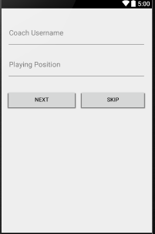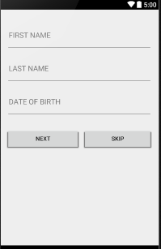

Step 5: You can optionally enter your Step 6: Finally, you can enter your  
personal information including Coach’s username if you have   
your First Name, Last Name, one, and your position.  
and Date of Birth

# Account Management:

At the end of this section, you will be able to make changes to your account profile.

# Guest Access:

At the end of this section, you will be able to access SkillCourt as a guest.

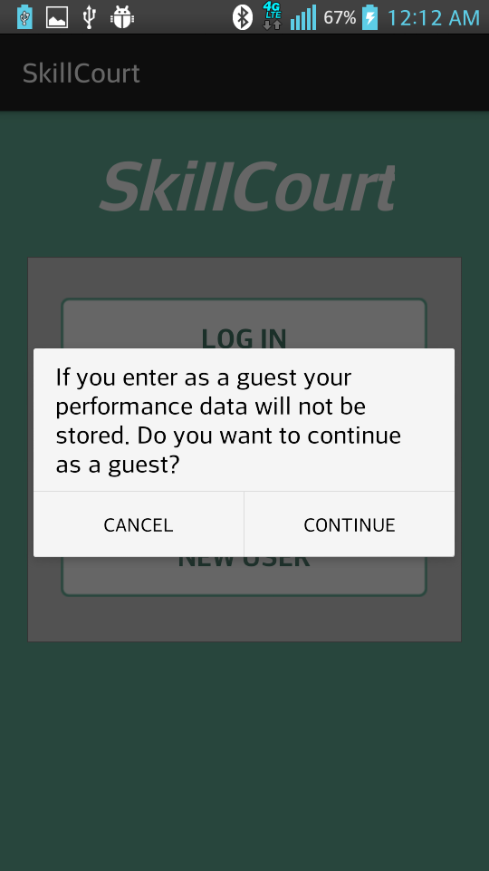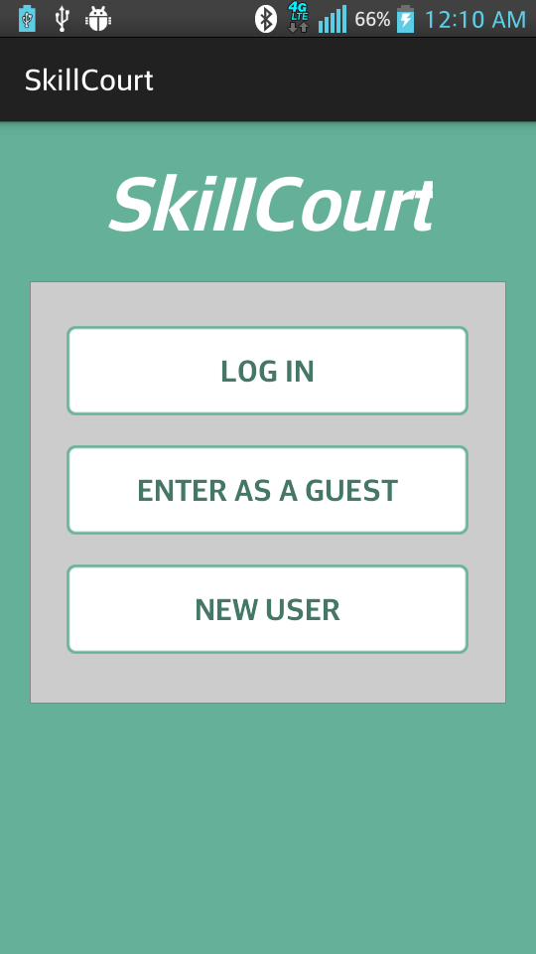

Step 1: Click the “Enter as a Guest” button. Step 2: Read dialog and click “Continue”

# Logging In:

At the end of this section, you will be able to log into your SkillCourt account.

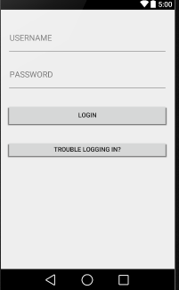



Step 1: Click on the “Log In” button on the Step 2: Press “Login” after entering your SkillCourt Welcome page. SkillCourt username and   
 corresponding password.

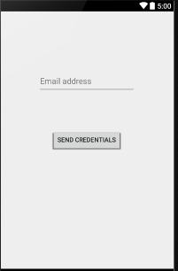

Step 2a: If you are having trouble remembering Step 2b: Here, enter your account’s  
your username and password, click on associated email address. The  
the “Trouble Logging In?” button system will retrieve your   
 account’s credentials and  
 email them to you.

# Logging Out:

At the end of this section, you will be able to properly log out of your SkillCourt account.

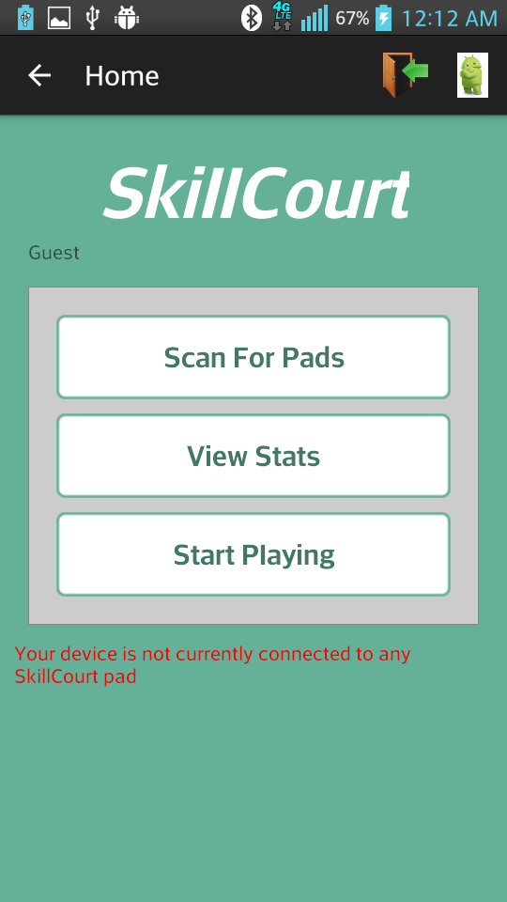

Step 1: Click the Logout icon on the top-left corner

# Routine Selection:

At the end of this section, you will able to choose your desired SkillCourt routine and begin playing.

# Access Performance Statistics:

At the end of this section, you will be able to access your best performance metrics, as well as a series of graphs showing your progress through time.

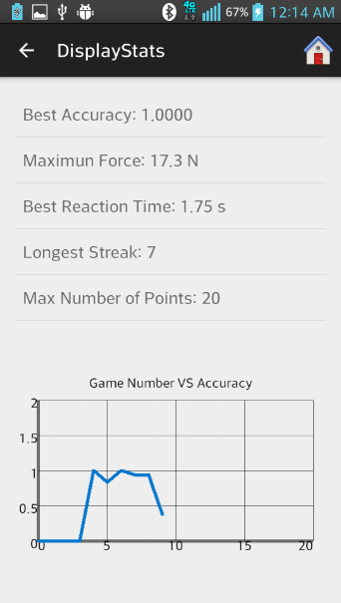



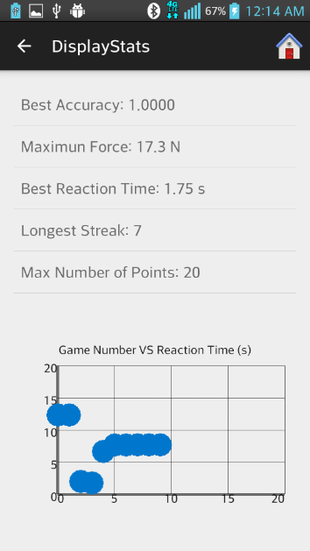Step 1: Click on the “View Stats” button on the Step 2: Click on the specific metric that you would like to see a line graph for.

Step 3: Click again on the same metrics to see a scattered graph with all data points